PROJECT

|  |  |
| --- | --- |
| ***construction company management system*** | **Abstract:**  Construction is the process of constructing a building or infrastructure. Construction differs from manufacturing. Manufacturing typically involves mass production of similar items without a designated purchaser, while construction typically takes place on location for a known client. Construction is directly tied to the fields of civil engineering and architecture. A construction company is responsible for building structures in the commercial and private sectors. In simple words, we can say that a construction company is a type of business, enterprise, or similar organization created and operating to construct a wide variety of buildings, developments, housing, path, pavement, roads, motorways, and other types of construction projects. A construction company involves lot of parameters like details of projects, employees, machinaries and raw materials.  Komal Singh |

“CONSTRUCTION COMPANY MANAGEMENT SYSTEM”

* AIM OF PROJECT :

The main goal of project of construction industry is to ensure that construction projects are successfully completed within the constraints of best quality, stated period and with minimum cost possible using ***MYSQL***

* INTRODUCTION :

Construction management (CM) is a professional service that uses specialized, [project management](https://en.wikipedia.org/wiki/Project_management) techniques and software to oversee the planning, design, and construction of a project, from its beginning to its end. The purpose of Construction management is to control a project's time / delivery, cost and quality—sometimes referred to as a [project management triangle](https://en.wikipedia.org/wiki/Project_management_triangle) or "triple constraints. CM is compatible with all [project delivery systems](https://en.wikipedia.org/wiki/Project_delivery_method), including design-bid-build, design-build, CM At-Risk and Public Private Partnerships. Professional construction managers may be reserved for lengthy, large-scale, high budget undertakings ([commercial real estate](https://en.wikipedia.org/wiki/Commercial_property), [transportation infrastructure](https://en.wikipedia.org/wiki/Transport#Infrastructure), industrial facilities, and [military infrastructure](https://en.wikipedia.org/wiki/Infrastructure#Military)), called capital projects.

* OBJECTIVE OF PROJECT :

1.The company will be able to easily track the details of **projects, employees, machinaries and raw materials.**

2. It will give a proper relation regarding which employees are working in which projects.

3. It will give details regarding how many raw materials are being allocated to each project.

4. It will help in tracking the machinaries linked to each project.

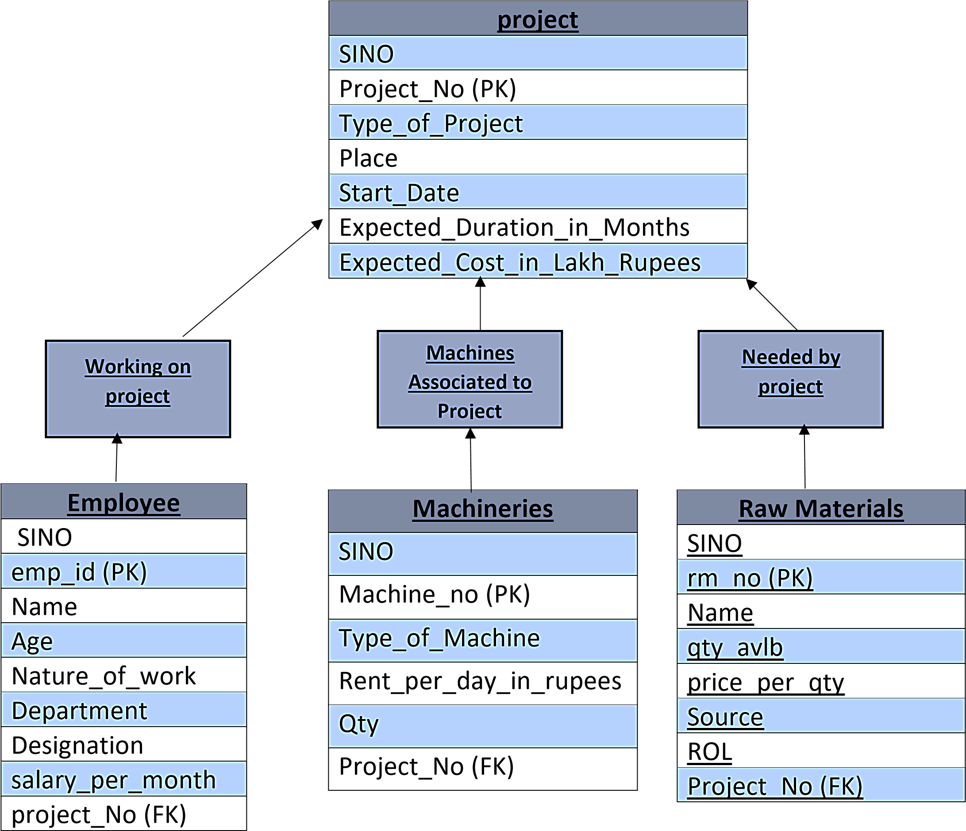

**STRUCTURE OF TABLE**

* **PROJECTS :**

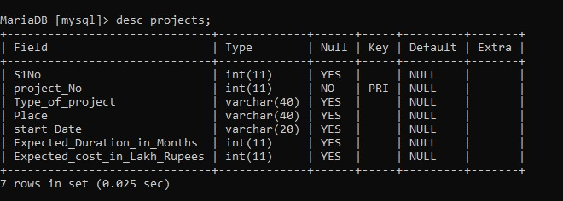

* **EMPLOYEES :**

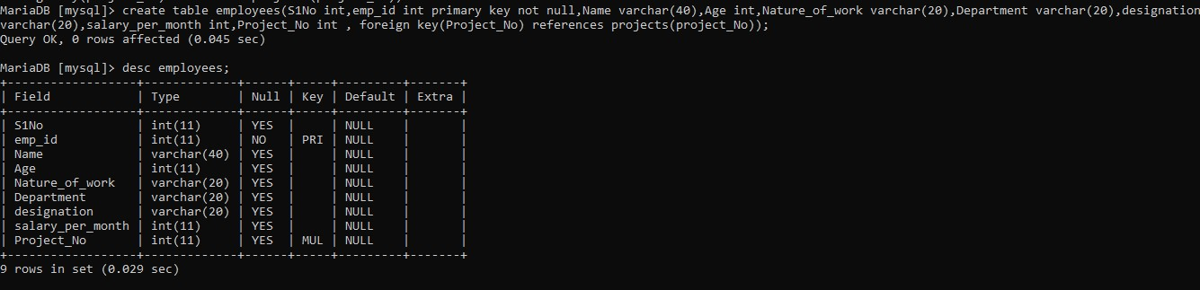

* **MACHINERIES :**



* **RAW MATERIALS :**

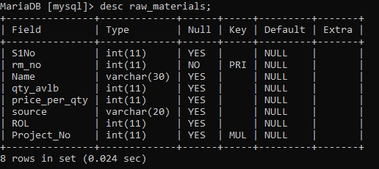

**CONTENTS OF TABLES**

**1.PROJECTS :**

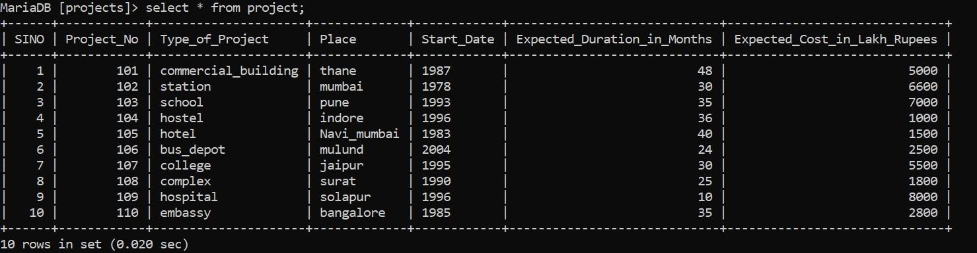

**2.EMPLOYEES :**

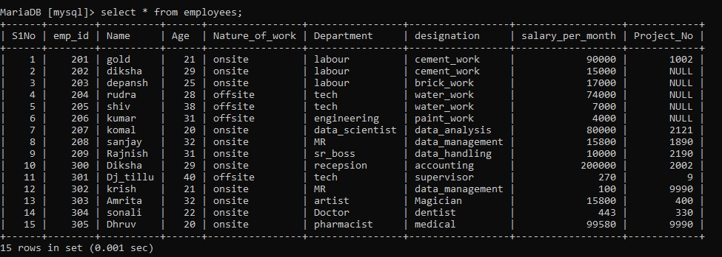

**3.MACHINERIES :**

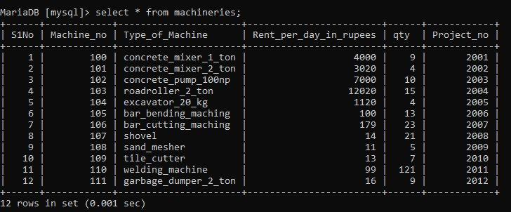

**4. RAW MATERIALS :**

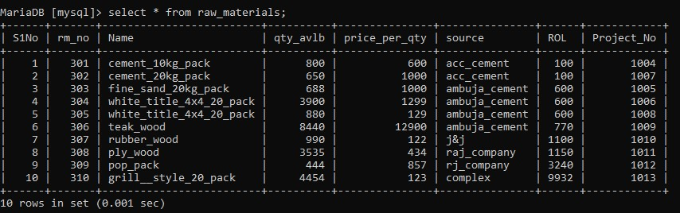

**VIEWS**

* **1.Create a table for employees and raw _materials associated with accview project**

**QUERY:**

MariaDB [projects]> create view accview as select employees.emp_id,employees.Name, employees.salary_per_month, raw_materials.rm_no, raw_materials.ROL from employees,raw_materials where employees.project_No in (400,330) and raw_materials.Project_No in (1004,1005);

# 

* **2.Create a table for the raw materials and machineries associated with residential building**

**QUERY:**

MariaDB [projects]> create view kssview as select raw_materials.rm_no,raw_materials.Name,raw_materials.ROL, machineries.Machine_no,machineries.Type_of_Machine,machineries.qty from raw_materials, machineries where raw_materials.Project_No in(1005,1006) and machineries.project_no in(2001,2009);

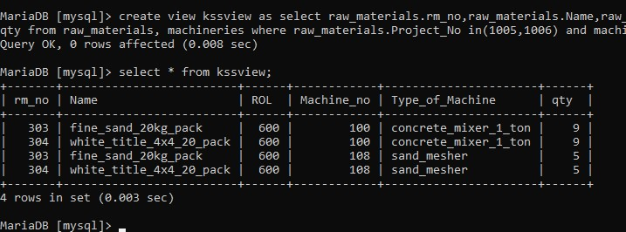

* **3.Show the employee and machineries associated with golview.**

**QUERY:**

MariaDB [projects]> create view golview as select employees.Name,employees.emp_id,machineries.qty from employees,machineries where employees.S1No in (3,4) and machineries.S1No in (3,4);

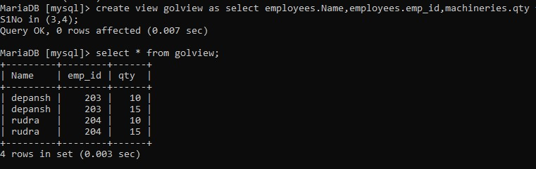

* **4. Update the detail of view:**

**QUERY:**

MariaDB [mysql]> update golview set qty=90 where emp_id=203;

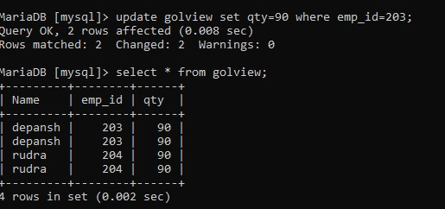

# **Joins**

* **1.Left join :**

**QUERY:**

MariaDB [projects]> select e.emp_id,e.Name,e.designation, p.Type_of_project,p.start_date from employees e left join projects p on e.S1No=p.S1No;

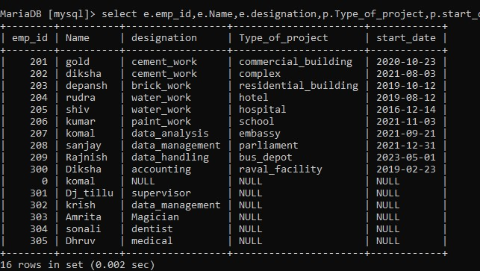

* **2.Right Join :**

**QUERY:**MariaDB [projects]> select e.emp_id,e.Name,e.designation, p.Type_of_project,p.start_date from employees e right join projects p on e.S1No=p.S1No;

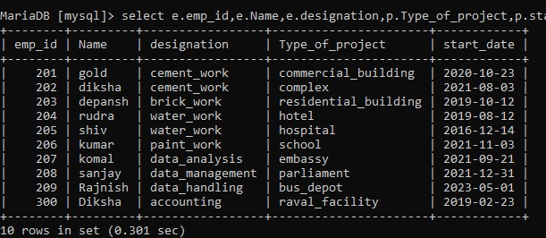

* **3.Cross join :**

**QUERY:**

MariaDB [projects]> select e.emp_id,e.Name,e.designation, p.Type_of_project,p.start_date from employees e cross join projects p on e.S1No=p.S1No;

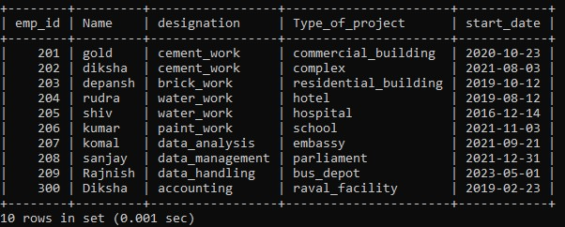

* **4.Inner join:**

**QUERY:** MariaDB [projects]> select e.emp_id,e.Name,e.designation, p.Type_of_project,p.start_date from employees e inner join projects p on e.S1No=p.S1No;

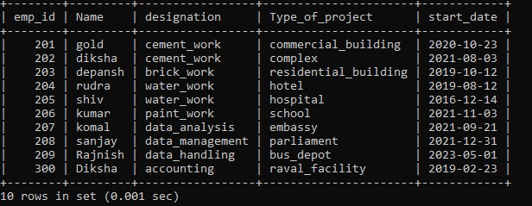

**SUBQUERIES**

* **1. Show the all the details of all the employees associated with hotel projects having salary> 10000**

## **Query :**

MariaDB [projects]> select * from employees where S1No in (select S1Nofrom projects where Type_of_project="hotel") having salary_per_month>10000;

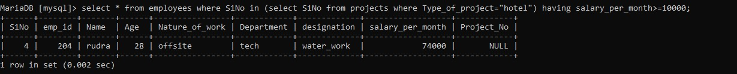

* **2.Show all the details of machineries and raw materials associated with projects having estimation > 3000 lakh crores**

**Query :**

MariaDB [projects]> select * from machineries where S1No in (select S1No from projects where Expected_cost_in_Lakh_Rupees>3000);

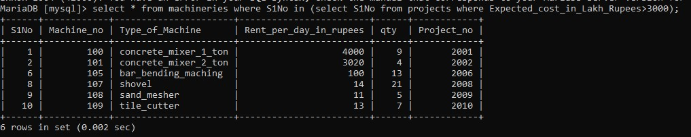

* **3. Show all the raw materials for college projects where qty available is more than 800.**

**QUERY :**

MariaDB [projects]>select * from raw_materials where S1No in (select S1No from projects where Type_of_project="embassy") having qty_avlb>800;

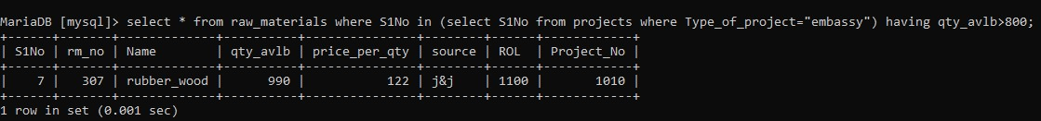

**BUILT-IN FUNCTIONS**

**1.MATH**

**2.STRING**

**3.DATETIME**

**4.AGGREGATE**

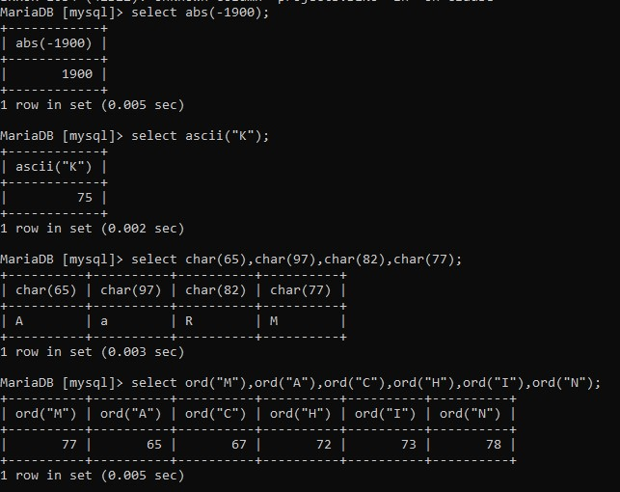

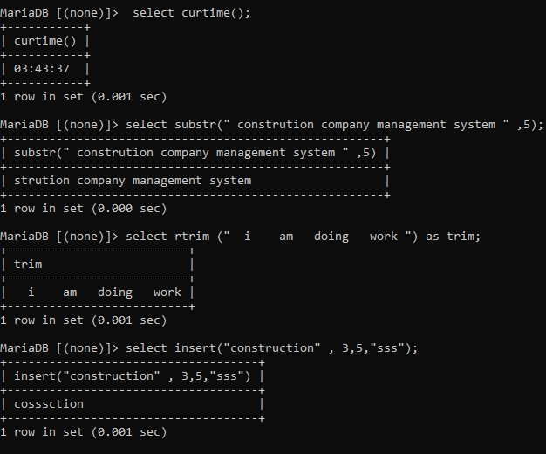

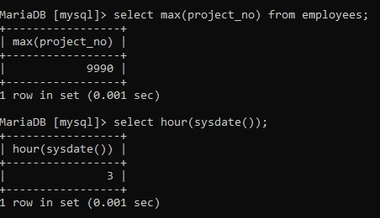

**THANK YOU**